# **Department of Computer Science and Engineering Islamic University of Technology (IUT)** A subsidiary organ of OIC

# **Lab Report 04**

# CSE 4412: Data Communication and Networking Lab

## 

## **Name: Khalid Hasan Ador Student ID: 210042102 Section: B Semester: Summer Academic Year: 2023-2024**

**Date of Submission: 18/02/24**

### **Title:** Understanding the basics of Inter-VLAN communication using Router, L3 Switch along with basics of Static Routing

### **Objectives**:

1. Design and implement Inter-VLAN routing using Router on a stick
2. Design and implement Inter-VLAN routing using Multilayer Switch
3. Understand and implement Static Routing

### **Diagram of the experiment:**

(Provide screenshot of the final network topology. Make sure to label the network components.)

**TASK 1:**

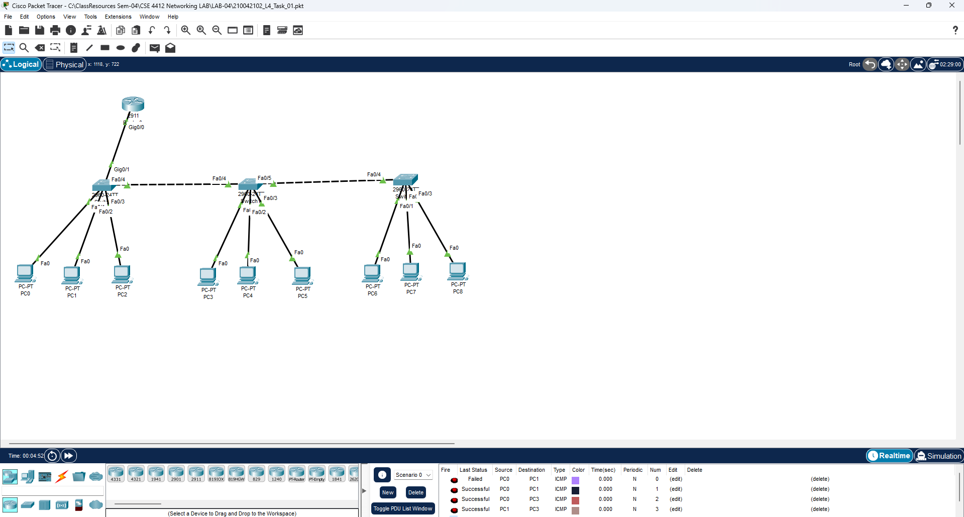

**TASK 2:**

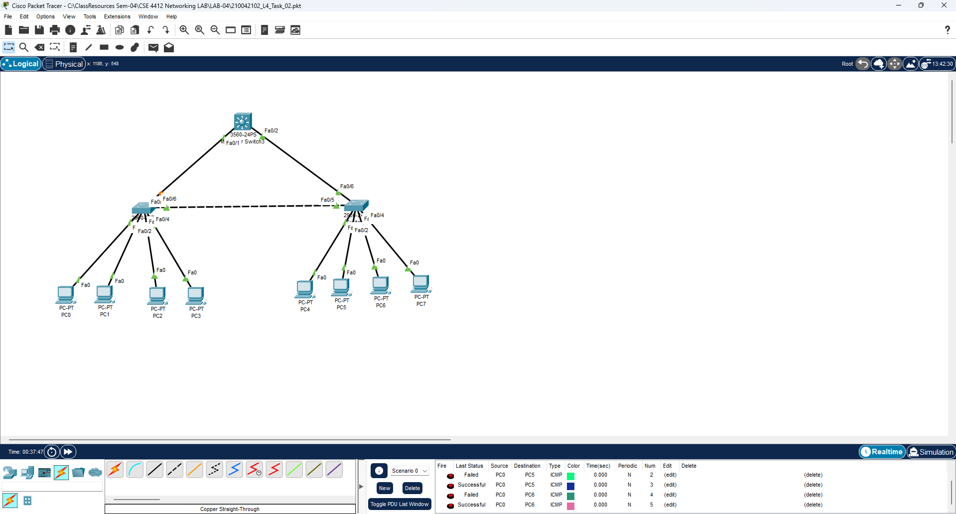

**TASK 3:**

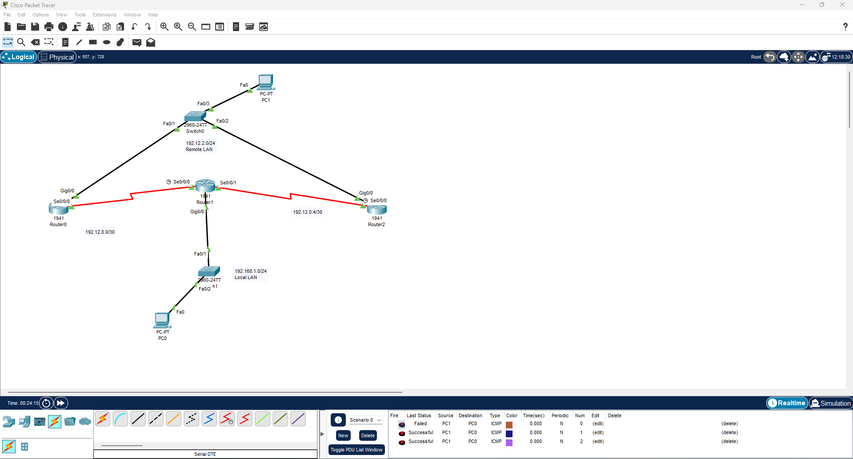

### **Working Procedure:**

**(**Explain in brief how you completed the tasks. Provide necessary screenshots of used commands for each task.)

**TASK 1:**

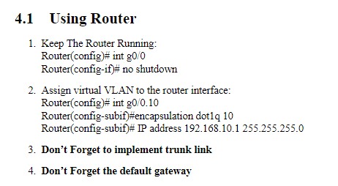

**TASK 2:**

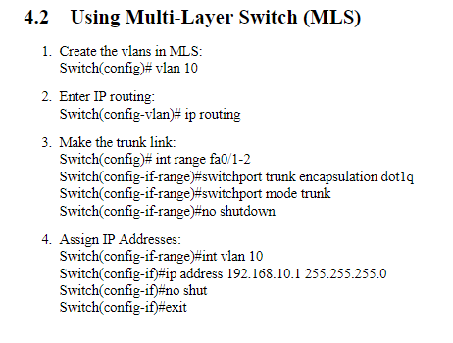

**TASK 3:**

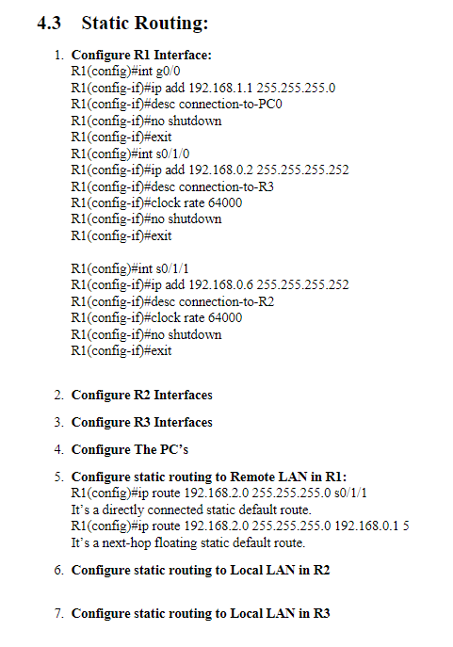

### **Questions (Answer to the point)**:

* + - 1. Why do we need L3 Switches?

**Ans:** Layer 3 switches are network switches that combine the functionality of a switch and a router. They are useful for handling large amounts of network traffic

* + - 1. What is the use router in Inter-Vlan Routing?

**Ans:** Transfer the packets from one VLAN to another

* + - 1. What changes are needed while configuring VLANs using L3 switches instead of Router-on-a-stick approach?

**Ans:** Need to create the VLAN’s again before configuring in case of L3 switches

* + - 1. What is next-hop floating address?

**Ans:** A floating IP can be the next hop for routing when F5s are in routed mode and a floating IP is configured for standalone or HA.

* + - 1. What is the disadvantage of static routing?

**Ans:**

* All changes have to be done manually
* Network administrator needs to know the whole network topology and network addresses to effectively configure the routing table.

### **Challenges (if any):**

1. Forgot to implement trunk link at first
2. Forgot to edit default gateway at first

### 

**REFERENCES:**

1. <https://www.manageengine.com/products/oputils/tech-topics/layer2-vs-layer3-switch.html#:~:text=Layer%203%20switches%20offer%20hardware,combine%20switching%20and%20routing%20capabilities>**.**
2. <https://www.cisco.com/c/en/us/support/docs/dial-access/floating-static-route/118263-technote-nexthop-00.html>